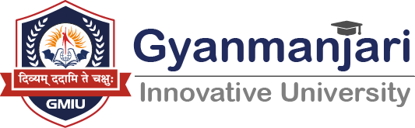

Gyanmanjari Institute of Law
Bhavnagar
Report on
RESUME BUILDING AND LINKEDIN PROFILE CREATION WORKSHOP

Date: 10/10/2025
Time: 10:00 AM to 12 PM
Location: FF-29 AND FF-28
LLB SEM- 1
Department | Law
Activity | RESUME BUILDING AND LINKEDIN PROFILE CREATION WORKSHOP
N0.of Students | 23
Faculty Co-ordinator |  | Mohit S. Bhatt  Prof.Tulsi Kondhiya

Objective:-
The workshop aims to equip students of Gyanmanjari Institute of Law, Bhavnagar with practical skills to design professional, impactful résumés and create optimized LinkedIn profiles that reflect their academic achievements, legal competencies, and career aspirations. It seeks to enhance employability and networking effectiveness by teaching participants how to articulate strengths, highlight relevant experiences, use industry appropriate keywords, and build a consistent professional identity across both documents and digital platforms.
About activity:
- The Resume Building and LinkedIn Profile Creation Workshop was conducted at Gyanmanjari Institute of Law, Bhavnagar on 10/10/2025 from 10:00 a.m. to 11:00 a.m. by Mr. Mohit S. Bhatt. The session aimed to strengthen students’ professional readiness by teaching them how to design impactful résumés and develop engaging, well-structured LinkedIn profiles tailored for careers in law and allied sectors. Using a detailed PowerPoint presentation and live demonstrations, Mr. Bhatt explained strategies for highlighting academic achievements, internships, and legal skills effectively, along with methods to optimize LinkedIn visibility and networking. The interactive activity helped students understand the significance of personal branding, digital professionalism, and employability in today’s competitive legal environment.

- A LinkedIn Profile Creation Workshop was conducted by Prof. Tulsi Kondhiya at Gyanmanjari Institute of Law, Bhavnagar on The session focused on enhancing students’ professional online presence and networking skills by guiding them in creating well-structured and impactful LinkedIn profiles. Prof. Tulsi Kondhiya explained the significance of LinkedIn as a global platform for career development, internships, and legal networking. Through live demonstrations and practical exercises, students learned how to craft effective headlines, write compelling summaries, highlight education, internships, achievements, and showcase their professional identity. The interactive activity encouraged students to build a strong digital portfolio aligned with their future career goals in the field of law.

